2017

1. A lens forms an upright and diminished image of an object when the object is placed at the focal point of the given lens
   1. Name the lens
   2. Draw a ray diagram to show the image formation [3 marks]

2016

1. A lens produces a virtual image between the object and the lens
   1. Name the lens
   2. Draw a ray diagram to show the formation of this image [3 marks]

2015

1. (i) Where should an object be placed so that a real and inverted image of the same size as the object is obtained using convex lens

(ii) Draw a ray diagram to show the formation of the image as specified in part (i) [3 marks]

2014

1. Ranbir claims to have obtained an image twice the size of the object with a concave lens. Is he correct? Give reason for your answer? [1 mark]
2. A lens forms an erect, magnified and virtual image of the object
   1. Name the lens
   2. Draw a labelled diagram to show the image formation [2 marks]
3. (i) Define the power of a lens

(ii) the lens mentioned in Q.2 above is of focal length 25 cm. Calculate the power of the lens. [2 marks]

2013

1. An object AB is placed between 2F1 and F1 on the principal axis of a convex lens as shown in the diagram. Copy the diagram and using three rays starting from point A, obtain the image of the object formed by the lens [4 marks]

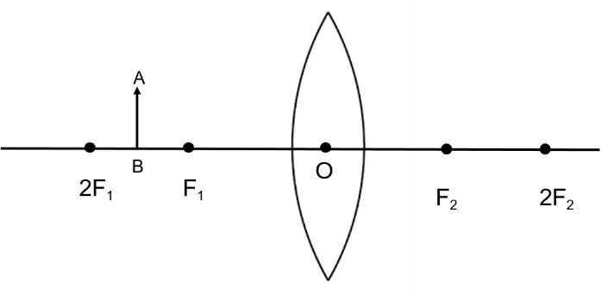

2012

1. You are provided with a printed piece of paper. Using this paper, how will you differentiate between a convex lens and concave lens [1 mark]
2. A converging lens is used to obtain an image of an object placed in front of it. The inverted image is formed between F2 and 2F2 of the lens
   1. Where is the object placed
   2. Draw a diagram to illustrate the formation of the image obtained [4 marks]

2011

1. (i) when does a ray of light falling on a lens pass through it undeviated

(ii) which lens can produce a real and inverted image of an object [1 mark]

1. An object is placed infront of a lens between its optical centre and the focus and forms a virtual, erect and diminished image
   1. Name the lens which forms this image
   2. Draw a ray diagram to show the formation of the image with the above stated characteristics [4 marks]

2010

1. We can a burn a piece of paper by focusing the sun rays by using a particular type of lens
   1. Name the type of lens used for the above purpose
   2. Draw a ray diagram to support your answer [1 mark]
2. An erect, magnified and virtual image is formed when an object is placed between the optical centre and principal focus of a lens
   1. Name the lens
   2. Draw a ray diagram to show the formation of the image with the above stated characteristics [4 marks]

2009

1. Copy and complete the following table [1 mark]

|  |  |  |  |
| --- | --- | --- | --- |
| Type of lens | Position of the object | Nature of image | Size of image |
| Convex | At F |  |  |
| concave | At infinity |  |  |

1. (i) Copy and complete the diagram to show the formation of the image of an object AB

(ii) what is the name given to ‘x’ [3 marks]

2008

1. Draw a diagram to illustrate the determination of the focal length of a convex lens using an auxiliary plane mirror [1 mark]
2. A linear object is placed on the axis of a lens. An image is formed by refraction in the lens. For all positions of the object on the axis of the lens, the positions of the image are always between the lens and the object
   1. Name the lens
   2. Draw a ray diagram to show the formation of the image of an object placed in front of the lens at any position of your choice except infinity [3 marks]

2007

1. An object is placed in front of a converging lens at a distance greater than twice the focal length of the lens. Draw a ray diagram to the formation of the image [1 mark]

2006

1. An object is placed in front of a convex lens such that the image formed has the same size as that of the object. Draw a ray diagram to illustrate this [1 mark]

2005

1. The given ray diagram illustrates the experimental set up for the determination of the focal length of a converging lens using plane mirror
   1. State the magnification of the image formed
   2. Write two characteristic of the image formed
   3. What is the name given to the distance between the object and optical centre of the lens in the given diagram [3 marks]

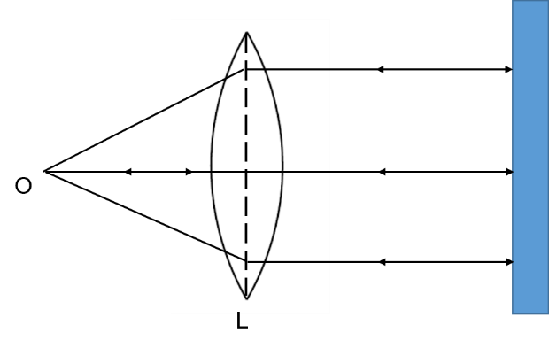

2004

1. The diagram given alongside shows an object O and its image I. copy the diagram and draw suitable rays to locate the lens and its focus. Name the type of the lens in this case [4 marks]

2003

1. A ray of light, after refraction through a concave lens, emerges parallel to the principal axis. Draw a ray diagram to show the incident ray and its corresponding emergent ray [1 mark]
2. State the characteristics of the image of an extended source, formed by a concave lens [3 marks]

2002

1. An erect, diminished and virtual image is formed when an object is placed between the optical centre and principal focus of a lens
   1. Name the type of lens, which forms the above image
   2. Draw a ray diagram to show the formation of the image with the above characteristics [4 marks]

2001

1. In optical camera
2. State the nature of the lens used
3. What is meant by f-number
4. State two characteristics of the image formed by the lens [4 marks]

2000

1. The diagram shows a point source of light S, a convex lens L and a plane mirror M. these are placed such that rays of light from S return to it after reflection from M.
   1. What is the distance OS called
   2. To which point (left of S or right of S) will the rays return, if M is moved to the left and brought in contact with L [1 mark]
2. Draw a ray diagram to illustrate the action of a convergent lens as a reading lens or a magnifying glass [4 marks]